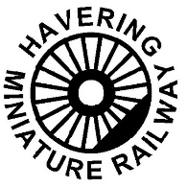 | HAVERING MINIATURE RAILWAY CLUB | 

Station Master

A Station Master duty involves -

- help and ensure safe loading and unloading of trains

- Keep the platform clear of people and objects

- Watch when train approaches and ensure line is clear

- Check/clip tickets

- Brief safety/information talk to passenger –

    - Keep feet and arms inside the coach – particularly keep feet on running boards for sit astride
    - Do not stand or lean
    - Do not get off until the train has stopped in the station
    - In emergency alert the driver by shouting STOP.
    - Explain about turning around at other end for sit astride coaches.

- If there is no train guard

  - Ensure the track ahead is clear
  - Ensure all passengers are ready
  - Dispatch train with a long single whistle and with a green flag if available

- If train guard then train guard will dispatch the train.

THREE LONG BLASTS ON A WHISTLE INDICATES HELP REQUIRED AND ALL TRAINS MUST STOP

Must ensure cover when leaving the platform.

If it is quiet then Station Master also deal with ticket sales. Use of rope or barrier is recommended to entrance gateway of the platform.

