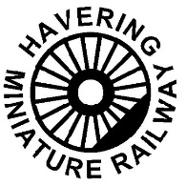 | HAVERING MINIATURE RAILWAY CLUB | 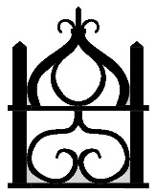

Train Guard

Due to the limit of two coach trains, train guards are not always necessary and can take up a revenue earning seat. The decision of whether a guard is needed will be made by the track marshal.

Reasons for a guard being provided

- Driver who needs accompanying (younger/junior member or visiting driver)
- Assistance to the driver when train is running in reverse direction
- Passengers who may have special requirements – e.g. all children passengers
- Train needs additional braking

A train guard’s duty involves -

- Taking responsibility for the passenger section of the train.
- Advising passengers of any safety issues (not to lean out from coaches and to keep feet on coaches fitted with side steps), stop the train if necessary
- Ensuring the train is correctly coupled together
- Help to ensure safe loading and unloading of trains
- Help with additional braking if they have access to brakes

Train guards act as a second pair of eyes for the driver and must alert the driver of any issues affecting the safety of the train. Guards will ensure that the single line token system is being operated correctly and if not will stop the train. If the driver is observed to be not adhering to rules then such matters need to be raised with the driver and if not resolved they must be reported to the Track Marshal. Matters of a serious nature must be reported directly to the Track Marshal.

- If a train guard is provided then the train guard will dispatch the train.

THREE LONG BLASTS ON A WHISTLE/HORN INDICATES ASSISTANCE IS REQUIRED AND ALL TRAINS MUST STOP. ANY TRAIN THAT IS STOPPED MUST NOT MOVE UNTIL INSTRUCTED TO DO SO

NOTES
There is no age restriction or specific insurance requirements for guards. General consensus (Northern Federation) seems to be that where more than three coaches are used guards will be provided.

When "top and tailing" trains with locos at each end of the train the rear driver in the direction of travel, will assume the role of the guard.

